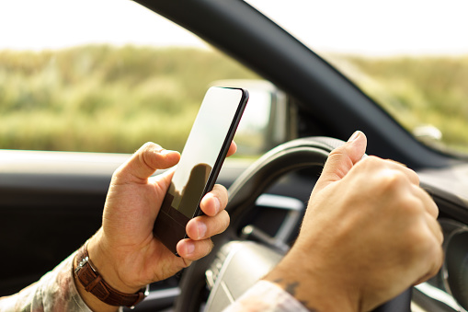

Sample Policy Template (Distracted Driving)
For reference only:

The use of hand-held mobile devices whilst in control of a moving vehicle is against the law and strictly prohibited by (Enter Company Name Here). You must never use/adjust or attempt to operate any type of hand-held mobile device while you are driving or manoeuvring a motor vehicle.
Only do so when you have stopped and safely parked with the engine/ignition switched off.
For the avoidance of doubt, even attempting to touch the screen of a mobile device while you are waiting in a traffic queue or at traffic lights is illegal in Great Britain and strictly prohibited by (Enter Company Name Here).
Hands-free/Bluetooth Systems
Only answer a call when you are driving if it is safe to do so and only if your device is paired to a hands-free/Bluetooth system. Inform the caller immediately that you are driving and that you can only take a brief message. Do not enter into a long conversation, confirm that you have received and understood the message and then end the call.
If you are making a call to, or receiving a call from, a mobile number, ask the person if they are driving. If they are, only leave or accept a brief message and then end the call. Under no circumstances is any driver permitted to dial into or engage in a teleconference such as Zoom or Microsoft TEAMS while they are driving or manoeuvring a motor vehicle.
You may use your mobile phone/in vehicle device to access information for the journey such as traffic news, but only if the device is 100% hands-free and securely mounted in a holder that does not obstruct your view of the road. Remember, if you are using a hand-held device such as a satellite navigation aid, you should set the device up prior to driving so it does not distract you during the journey.
You should never attempt to adjust the settings on any type of satellite navigation device (built in or windscreen mounted) or retune your radio whilst you are driving as this can result in distraction. In addition, if you are stopped by the police in Great Britain for using a hand-held mobile device, you will face a fine up to £1,000 and six penalty points on your driving licence.
The only time that you can use a mobile phone when driving is to dial 999 in an emergency but only if it is not safe to stop. If during your journey you need to use your handheld mobile device, you must first pull over to the side of the road or other safe location and only use it when you have parked your vehicle with the engine/ignition switched off.

All staff driving on Company business including, company car and privately-owned car drivers must adhere to this policy and consider the following:
- Changing your voicemail greetings to indicate that you are not available to answer calls or return messages while driving.
- Informing clients, associates and supply chain partners of our policy, so they understand why their calls may not be answered/returned immediately.
- Any passenger is allowed to use their handheld or hands free device at any time, as long as it does not distract the driver.
- If you are involved in a road traffic collision, records of your mobile phone/in-vehicle device use will be checked by the police.
- Any contractual obligation from a client, such as an outright ban on the use of mobile/in-vehicle devices whilst driving, must be strictly adhered to.

For clarification or further information please contact:
Protector Insurance UK Risk Management Team
Risk@protectorinsurance.co.uk

Disclaimer:
Please note that the Information contained herein has been provided to you for general information purposes only and is considered confidential and/or privileged information, which you must not distribute to any third party, in whole or part, without Protector’s express written permission. Whilst all reasonable care has been taken to ensure that the information in this document is comprehensive and accurate, Protector makes no representation, warranty or undertaking, express or implied, as to the accuracy, reliability, completeness or reasonableness of the Information. Any assumptions, opinions and estimates expressed in this document constitute Protector’s judgment as of the date thereof and are subject to change without notice. Any projections and/or proposed risk mitigating solutions contained in this document are based on a number of assumptions as to existing risk conditions and there can be no guarantee that any projected outcomes will be achieved, nor that no other risks exist. Protector does not accept any liability for any direct, consequential or other loss arising from reliance on the contents of this document, and provides no guarantee that recommended remediation measures supersede, or replaces any statutory obligation

